**INTERNATIONAL UNIVERSITY GG CAMPUS**



**Lab 03**

**Submitted to:** Hafsah Mehmood

**Submitted by:** Bibi Sadiqa

**Sap ID:** 44804

**Course:** Database Management system

**Task 1:**

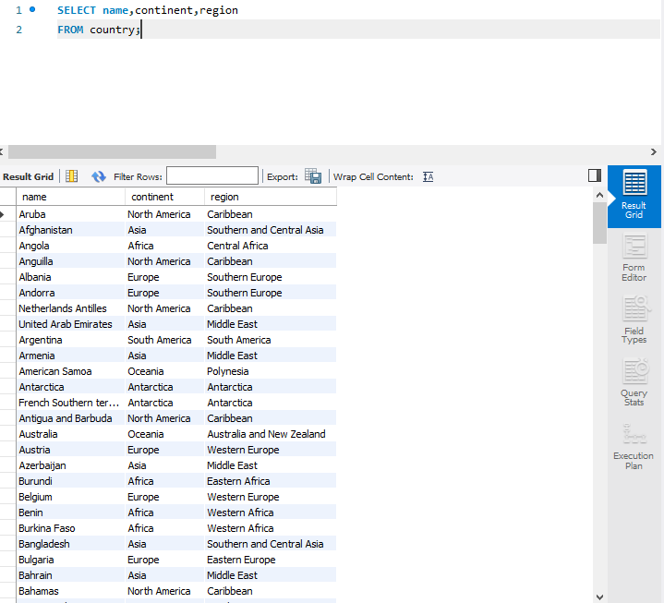

**Task 2:**

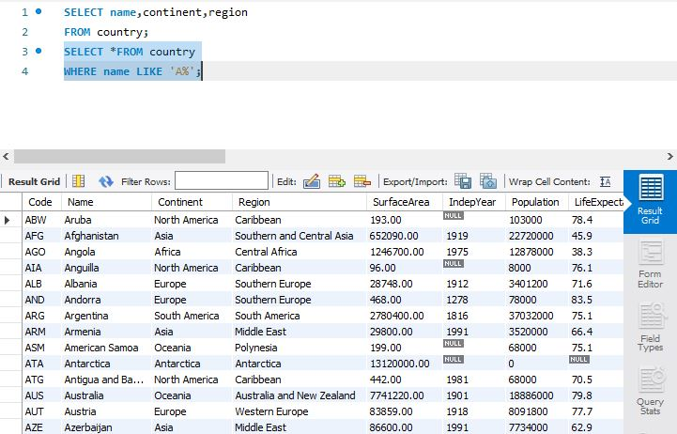

**Task 4:**

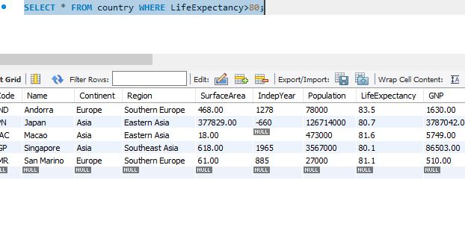

**Task 5:**

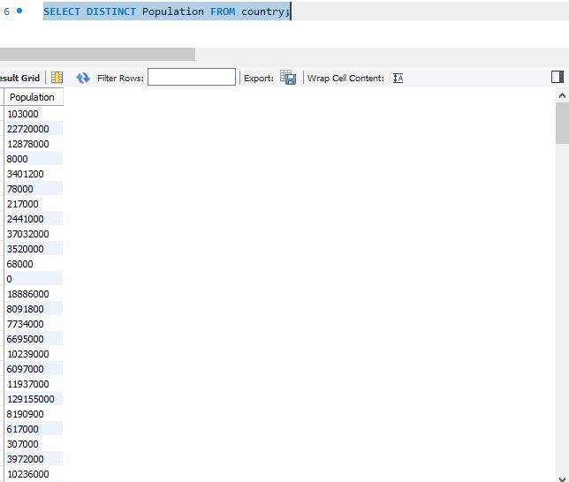

**Task 6:**

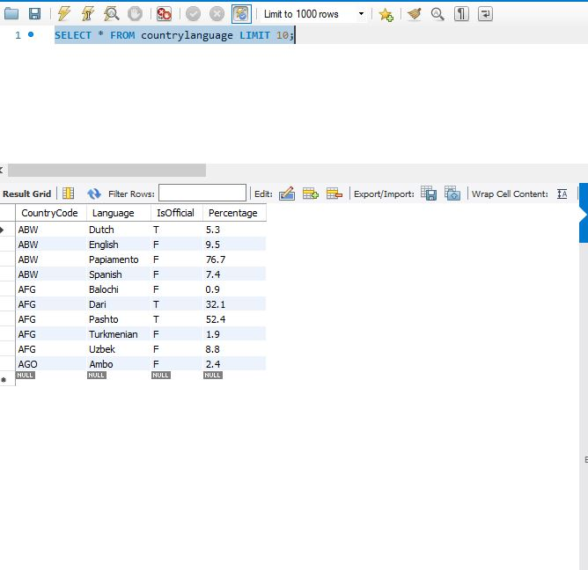

**Task 9:**

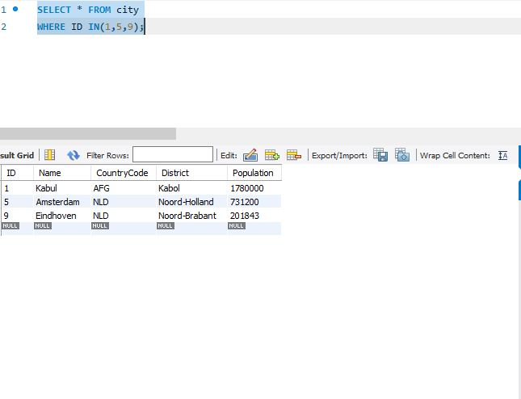

**Task 10:**

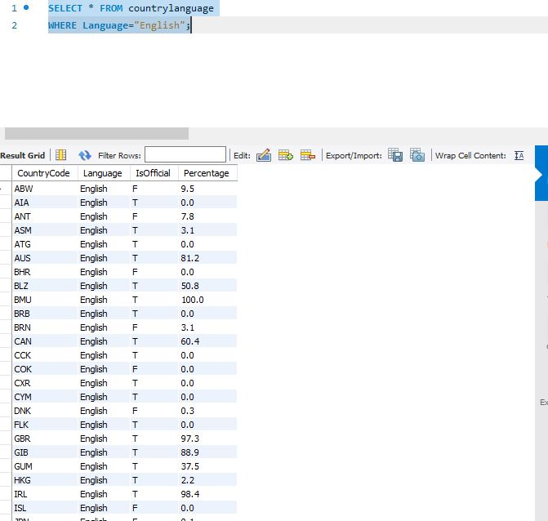

**Task 3:**

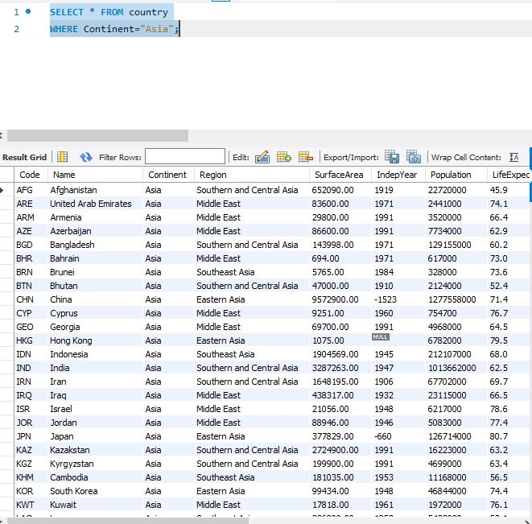

**Task 8:**

